THE SIGNIFICANT CONTRIBUTION OF SOUTH AFRICA'S INFORMAL ECONOMY TO ECONOMIC GROWTH AND THE LABOUR MARKET

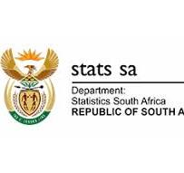

A Research Project Report
Presented to
The Department of Mathematics and Physics

by

Mkhonto Hendry Mike
STUDENT NO. 221026908

As an Assessment for the Module
MATHEMATICAL SCIENCES PROJECT 3 (MSP360S)
Within the Qualification
DIPLOMA IN MATHEMATICAL SCIENCES

ACADEMIC SUPERVISOR: Dr G. Buzuzi
COMPANY MENTOR(S): Zukile Ncapayi

Cape Peninsula University of Technology
July 2024

DECLARATION
I, Mkhonto Hendry Mike, declared that the contents of this research report represent my work. I know that plagiarism is wrong. Plagiarism is to use another's work and pretend that it is one's own. Each contribution to, and quotation in, this report from the work(s) of other people has been attributed and cited and referenced.
I have not allowed, and will not allow anyone, to copy my work to pass it off as his or her work. Declaration
Click on the box to confirm your agreement: ☒
Date of: 15 July 2024
ACKNOWLEDGEMENTS
I want to thank God for giving me this opportunity to my qualification to the end. I want to express my gratitude to all the people who contributed to the completion of this project to the end. It will be a great honor to thank my company mentor Mr. Zukile Ncapayi and my academic supervisor Dr G. Buzuzi for their contribution and guidance throughout this project. Your expertise and encouragement have sharpened my knowledge to do better and give a positive outcome to this report.
I'm grateful to my colleagues, and family for checking up on me and motivating me during this journey. Their words of encouragement motivate me to be perseverance. I would like to thank Statistics South Africa and Mr Sive for allowing me to use their data in completing my research. Without your cooperation, my research would not be successful.

TABLE OF CONTENTS
DECLARATION..............................................................................................................ii
LIST OF TABLES...........................................................................................................iii
LIST OF FIGURES.........................................................................................................iii
LIST OF SYMBOLS AND ABBREVIATIONS...........................................................iii
GLOSSARY OF TERMS................................................................................................iii
ABSTRACT......................................................................................................................iii
- INTRODUCTION ......................................................................................................3

- LITERATURE REVIEW...........................................................................................3
- METHODOLOGY......................................................................................................3
- RESULTS AND DISCUSSION..................................................................................3

- CONCLUSION AND RECOMMENDATIONS.......................................................3
APPENDIX A. ...................................................................................................................3
REFERENCES...................................................................................................................3

LIST OF TABLES
Table 1.1 Key Variables of QLFS Q4: 2023.
Table 1.2 Display summary of binary logistic regression.
Table 1.3 Distribution Summary of Chi-square.
Table 1.4 Display of Odd Ratio from the logistic coefficient.
Table 1.5 Descriptive Statistics of Informal Economy

LIST OF FIGURES
Figure 1.1 Distribution of Informal Employment by Population group.
Figure 1.2 Percentage of Persons in Informal Employment by Gender and Education Status
Figure 1.3 Relationship of Province and Employment Status by Province.
Figure 1.4 Relationship of Employment Status by Gender.
Figure 1.5 Relationship of Metro code by Province in each Sector.
Figure 1.6 Relationship of Age group of each Sector.

LIST OF SYMBOLS AND ABBREVIATION
1. PND- National Development Plan
2. SACP- South African Community Party
3. LFS- Labor Force Survey
4. DTI- Department Trade and Industry
5. QLFS- Quarterly Labor Force Survey
6. GDP- Gross Domestic Product
7. ILO- International Labor Force
8. ICLS- International Conference Labor Statistics
9. WIEGO- Women Informal Employment Globalization Organization
10. SEWA- Self-Employed Women’s Association
11. PPP- Public-Private Partnerships
12. NGO- Non- Governmental Organization
13. StatsSA- Statistics South Africa
14. UIF- Unemployment Insurance Fund
15. ANC- African National Congress
16. RDP- Reconstruction Development Program
17. NPC- National Planning Commission
18. COSATU- Congress of South African Trade Unions
19. SADC- Southern African Development Community
GLOSSARY OF TERMS
The formal sector: refers to a sector of employment that the government regulates and that is registered for income tax.
The informal sector: refers to the production of enterprises in an economy that are not registered by the government and not having legal paperwork to work in the formal economy.
The informal economy: These are economic activities that have market value and that are neither taxed nor monitored by the government.
Informal employment: This is a working arrangement in the informal sector that is not regulated by the government this includes lack of infrastructure, lack of access to funding and unregistered.
Turnover: Total revenue of sales generated in a business by workers during a specific period. This includes any income coming from sales of goods and services that are not coming from the business.
Labour market: This is the place where workers and employees meet in relation to terms of supply and demand of labour.
Unemployment rate: Measure the percentage of the economically active population who are seeking jobs or are not employed.
Employment: is defined as the relationship between employer and employee, where the employer provides labour in exchange for salary or wages under an agreement
Economic sectors: refers to a category of economic activities which allows for a better understanding of how different areas contribute to economic growth that involves primary, secondary and tertiary sectors.
Rural economy: This is defined as the total average of economic activities that happen in rural areas such as the agricultural sector, trade, services and manufacturing.
ABSTRACT
South Africa, as a developing country, is facing multiple challenges such as poverty, unemployment and inequality. Approximately millions of entrepreneurs depend on the informal economy for the survival of income and job opportunities in the informal sector. Without economic activities in the formal sector, the poor and uneducated rely on the informal economy to secure livelihoods. This study seeks a framework to examine the contribution and constraints of the informal economy in the Western Cape Province and its contribution to economic growth in the Central Business District of Cape Town. A quantitative approach is used to measure to research the impact of the informal sector on economic growth. Statistical software R was used to analyze the significance of the research data. To ensure the validity and reliability of this research, a logistic regression instrument is used. The findings of this study indicate that approximately 70.3% of economic growth is indicated by employment status, government support, legislation, and good infrastructure and the is 29.7 % by informal economy. This study applies a correlation and binary logistic regression model for the analysis of the informal economy at a 5% level of significance, where p-value=0.49. The findings of this study reveal that the challenges most informal economies face are limited access to financial support, business infrastructure, lack of training and no government support. Based on the findings of this study it reveals that the informal economy contributes positively to the economic growth and livelihoods of those involved in the informal sector through generating income, job opportunities, and business incubation. This study concludes that due to an increase in the unemployment rate in South Africa, the government must rethink their policy that support the informal economy and acknowledge the informal sector by providing training to entrepreneurs. This study recommends that the government should form partnerships with informal economies and formal ones to provide a positive network for economic growth.

Keywords: Informal sector, Formal sector, Labour Market, informal employment

INTRODUCTION
Kabeer (2008) states that around the world, the informal economy plays a significant role in the national economy, social and political to help maximize the informal sector's contribution to economic growth and maintain social justice and participation for all labour. This research investigates the economics and impact of formalization on labour according to the employment sector, age, gender, education level, employment status and marital status. Street sellers, hawkers, and spaza stores are just a few examples of the unregistered businesses that make up the informal sector (Ligthelm, 2004). Most countries gained political independence in the 1950s and 1970s and South Africa became politically independent in 1994, when the ANC, Cosatu and SACP were formed. The post-1994 policy and strategies were formed toward the socio-economy that created the Reconstruction Development Programmer (Ntuli, 2020). However, as the government fails to encourage this sector, it is difficult for it to become formalized and to gain access to resources. Despite having difficulties gaining access to social security programs, women make significant contributions to the informal sector by helping to bring the whole nation out of poverty (Vanek & Chen 2014, pp. 47-59).
The interaction of different races, genders and classes has impacted women's economic opportunities and integrated into the formal economy. Brown (2010) suggests that the government's formal regulation of the informal economy is necessary to bring the full potential of the economy by providing access to legal support: technology, financial services and training, especially for women-led businesses. The government's overall policy document predicts meeting the country's unemployment reduction target, which will be necessary to create between 1.2 and 2 million new jobs in the informal sector by 2030, which will also involve domestic work for South African citizens (Fourie, 2019). Despite the document's lack of detail, it does not provide any guidance on how to expand existing policies to support the informal sector and its growth in alignment with the overall employment growth.

Background
History of the informal economy
The roots of South Africa's informal economy can be traced back to apartheid when discriminatory policies excluded black South African citizens from the formal economy due to being unregistered (Skinner, 2002). Despite the end of apartheid in 1994, the informal economy continues to thrive in challenges due to factors such as high unemployment, economic inequality, and limited access to capital. According to Hussmanns (2004), approximately 22% of employed citizens were engaged in informal sector activities to support themselves and their dependents and loved ones due to a lack of opportunities in the formal sectors.
The informal sector has been acknowledged as a crucial aspect by the South African government, including President Thabo Mbeki and the Department of Trade and Industry (2003). South Africa's first democratic government started in 1994 at the end of the apartheid era and developed integrated strategies that will be able to address the high levels of inequality in communities across the country. According to the Quarterly Labor Force Survey (QLFS) in the fourth quarter of 2019, the unemployment rate was projected to be 29.1% (Statistics South Africa [StatsSA], 2020a, p.1). The growth of the Gross Domestic Product (GDP) decreased by 0.8% in the same year in the third quarter, followed by a decrease of 1.4% recorded in the last quarter (StatsSA 2020b, p. 2). This project seeks to introduce fresh perspectives on the informal economy in South Africa. A thorough statistical analysis is available to shed light on the characteristics, structure, and relationship of the informal to the formal sector.
For 10 to 20 years, the informal sector of food production in South Africa has been valued at R87 billion per year. At the same time, the backroom rental industry generates rental income of approximately R30 billion ($1,643,556,000) annually in the residential sector. According to Rogan and Skinner (2017), the above-mentioned viewpoint suggests that more than 2.5 million people are working in the informal sector in South Africa.

Defining the Informal Sector:
According to the British anthropologist, Hart (1973) came up with the idea for an article about Kenya's economic efforts in the 1950s and 1960s. According to Hussmanns (2004), the informal economy is characterized by the characteristics of the individuals involved and their professions, rather than those of companies that are employed with them. It was later published as an essay by Hart and a report by the ILO. The ILO defines the informal sector as encompassing employment beyond major cities, specific professions, and commercial or informal activities. Due to the economic crisis in 1980, employment was expanded beyond this definition by the inclusion of the informal sector as a source of employment alongside open unemployment (Tokman, 1980). The Fifteenth International Conference of Labor Statisticians (15th ICLS) defined the informal sector in 1993 based on the features of the enterprises that covered all workers in at least a single manufacturing unit of the informal sector, despite their employment status and whether they were employed in primary or secondary capacity (Hussmanns, 2004).
Size, Extent and Structure of Informal Enterprise:
The informal economy has increased globally since the 1970s. The informal sector employs over 2 billion individuals over the age of 15 and above, making up a group of approximately 61.2% of the world's total working population (Delgado-Prieto, 2024). The largest country in the Southern African Customs Union is South Africa, which also suffers the greatest inequality. According to the World Bank's global poverty database, South Africa is highly ranked the first out of 164 countries in the world. South Africa's unemployment rate was reported to be approximately 33.95% Quarterly Labor Force Survey was conducted by Stats SA in the second quarter to determine the economic growth of South Africa. Women in Informal Employment Globalization and Organizing are explained as the source of the experiences they encounter, insights, and findings that have a primary goal of improving the livelihood of citizens to have equal rights and economic opportunities for all. WIEGO is part of an international movement for women in the informal sector and has been focusing on gender equality for all people around the world, inspired by the Self-Employed Women's Association (SEWA) that was founded in India. The movement comprises two global alliances, that led to HomeNet and Street Net, which now are known as homeworkers (general workers) and street vendors. To determine the extent of the informal economy in South Africa, Thomas (2012) made efforts to measure its nature and size. Kantor (1999) suggested that the gap between gross domestic product (GDP) and gross domestic expenditure should be included in GDP for a more precise measure of economic activity in South Africa. According to Thomas, South Africa's real GDP was approximately 30% greater than official statistics. It includes all illegal income-generating activities that people use to make a living.
The informal sector's contribution to GDP:
Africa's education level system has a strong correlation with informality, with 94 % of the total made up of non-formal students and those who have no education are also employed in the informal sector. The informality rate has decreased for those with primary education to those with secondary education in South Africa. Individuals possessing a higher education level have fewer chances of participating in informal jobs because of the skills they learn. Almost half of the educated population in West Africa has a negative correlation with their education, making it less noticeable and most are informal. Informality is the main characteristic of employment rates, both in rural and urban areas. Almost the entire agricultural sector in Africa is informal because most people are surviving using the agricultural sector to make a living.
Formal economic activities are mostly found in the Central Business District in Cape Town, where there are corridors such as CBD, Bellville and Mowbray which account for 34% proximate population. The industry was instrumental in job creation, serving as a buffer against the high official unemployment rates because most informal sector comes from the education level who couldn't get to tertiary level. According to Ngcobo (2021), state that most people were affected by the COVID-19 pandemic most likely women, disabled people, youth and elderly. From the year 2015 to 2023 global youth unemployment rose from 12.9% to 13.2% in the informal economy.

Research Problem
This research aims to investigate an effective approach in Western Cape province for the year 2023, to formalize the informal economy in South Africa, which will help increase its contribution to economic growth, employment creation, and tax revenue while maintaining social security for informal workers. According to Rogerson (2018 pp.157-171), point that the more the province has a large number in the informal sector the stronger the foundation to be able to move from the informal to the formal sector because as the economy grows also the firms grow and become competitive sector.

Research Questions
1. What is the current state and structure of the informal economy in South Africa?
2. What are the primary challenges that informal businesses encounter in South Africa?
3. What economic advantages can be used to formalize the informal economy in terms of gross domestic product (GDP) growth, employment creation, and tax income?
4. Which methods can be used by civil society, businesses, and government to work together to successfully adopt a formalization strategy?

Research Objectives
The primary objective of this study is to investigate the nature and extent of the informal sector in the labour market in the City of Cape Town, and its contribution to the South African economy on economic growth.
The secondary goal of the study is to determine the current size of the informal economy, how much it contributes to economic growth and the employment rate. It also aims to explore the relationship between the formal and informal sectors, identify challenges faced by the informal enterprises, and suggest policy recommendations. Additionally, this study focuses on demographic participants that are most visible in the informal sector such as education level, age and gender disparities in the City of Cape Town in 2023.

Research Hypotheses
H0: South Africa's informal economy can benefit from targeted policy interventions, infrastructure development, and vocational training to achieve economic growth, job creation, tax revenue generation, and livelihood.
H1: The rise in the number of informal workers in Cape Town corresponds positively to the total employment rate in South Africa.

Significance of Research
This study is significant because it seeks to explain how the Western Cape informal economy contributes to economic development in South Africa in the labour market. The research project will provide findings that help guide legislation of informal, improve job opportunities, and encourage the growth of entrepreneurs by focusing on the objective of formal regulation through NDP. According to the Rodríguez-Pose (2002) suggest that the informal economy has a positive impact on GDP that produces 29% of PPP in South Africa. The government suggest that it plans to create 2.5 million jobs using the process of the informal economy.
The purpose of this study is to find a way from informal to formal enterprise to indicate the possibilities of lowering the unemployment rate and raising living standards for South African citizens in urban and rural areas. The informal sector is often identified by a high level of innovation and entrepreneurship in the industry. This study will look at how formal regulations could assist businesses to prosper by giving informal businesses the resources and skills they desire.

2. LITERATURE REVIEW
South Africa's informal economy plays a big role in regulating economic growth by working with private organizations such as street vendors, spaza shops hawkers etc. In the history of the country, it is rooted that during the apartheid era, there were discriminatory policies of inequality, but the informal sector continues to play a significant role in employment and poverty elevation in South Africa (Seeking & Nattrass, 2008). This research aims to study the informal enterprise in South Africa that involves the historical context, current size and structure, challenges and the significant benefits of formalization.
McKeever (1998) states that the origin of the Informal economy in South Africa was tied to the apartheid era, where the system of racial exclusion declined the opportunities for formal enterprise. Secondary apartheid led to an effort to interact with the formal economy to integrate income with the communities, the informal economy rebelled due to a high unemployment rate, limited access to capital and economic inequality (Rogan & Skinner, 2017). According to the Labor Force Survey data, the is approximately 22% of people engaged in informal enterprise organizations due to a lack of opportunities in the formal economy. South African administrations have acknowledged the informal sector's role including President Thabo Mbeki's government and the Department of Trade and Industry (Johnson, 2016). Nevertheless, the acknowledgement that the has been insufficient policy development in the formal enterprise has led to an effective integration in the economic growth (StatsSA, 2011).
Education level has a negative significant relationship with the size of the informal economy. Labor Force participation rates have increased from 40% to 43.3% of women with fewer matric qualification points than men. In the past 10 years, it shows that we face gender disparity in unemployment in South Africa at all education levels. Hart (1973) created the phrase 'informal sector' in the 1970s and defined it as a group of small-scale businesses that are not captured by the economic official statistics in Ghana.
The International Labor Organization has expanded the definition of informal economy across different organizations. The informal enterprise is defined by its employees who are in unregistered organizations and who cannot move to the formal sector due to a lack of assistance (Tokman, 1980). The informal economy has other features characterized in South Africa:
- People working in the informal sector most of them have a lower level of education than those in the formal economy. This problem limits their potential to make it to the formal sector and this indicates why most people remain in the informal sector for some time (Heintz & Pollin, 2003).
- According to my perspective, most black Africans are mostly forced to stay in the informal economy, while the white citizen is looking the informal sector as a temporary fallback (McKeever, 1998).
- Migrants in the informal economy show that they are the most foreign-born laborers in Cape Town and Pretoria which leads to competition for limited job opportunities.
According to Rogan and Skinner (2017) state that the domestic growth product (GDP) in South Africa’s informal sector is substantial and has contributed to almost 10- 12% of the economic growth. In the effect of the post-COVID-19 pandemic in 2021, the informal sector remains crucial, but the contribution was expected to grow to 10-15% from the World Bank. The most significant informal sector is found in the urban areas where the employment rate is double that in rural areas. The informal sector has suffered a severe impact in South Africa due to challenges such as lack of finance, limitations to infrastructure and insufficient training (Thomas, 2012). Capital is the most common problem most informal sectors face all the time and even the government is neglecting it, but the only goal is to expand economic production. Start-up capital in the informal sector is often a struggle because most people are inability to secure loans (WIEGO, 2012).
Gender inequality is a challenge in every country, among youth and women who play a big role in contributing to the informal sector, facing barriers to having access to social security, training and resources (Simelane, 2022). Challenges to formalization are reducing the economic growth of the country because the government makes registration costs expensive, and the informal sector is afraid of losing existing customer bases (Kantor, 1999). Local economic growth is viewed as a strategy for moving forward that can benefit the country by creating job opportunities, reducing poverty and increasing GDP growth. The informal sector can provide formalization with access to financial services, technology and legal support (Skinner, 2002).
According to Hart (1973), he states economic formalization can improve working conditions and the rights for labour within the informal enterprise. The linkage between informal and formal enterprises could improve economic growth and help the informal sector to move to formal. According to the National Planning Commission, the formalization of government policy must provide the informal sector with rights to boost South African economic growth. The has not been enough legislation policy to guide the municipalities to create a sustainable environment for economic growth by promoting and developing the informal sector.
Migrant and refugee entrepreneurs are mostly likely to be found in South Africa, especially in the City of Cape Town and they make the competition higher for informal workers. According to the SADC, there are likely 20 different countries entrepreneurs such as Nigeria, Zimbabwe, Somalia, Congo, Ethiopia and India that are coming to South Africa for a better life. The Mayor of Cape Town states that refugee has value in the informal sector because they boost the economy (De Lille and Kesson, 2017). Most refugees face difficulties because they must pay for protection fees, if not their business will be destroyed or closed (Tawodzera & Chikanda, 2016). The Somalia Community Board states that around 400 Somali informal trader refugees were killed in South Africa around the year 2002 to 2010.
King and Shackleton (2022) argue that the government of Eastern couldn't afford to cover daily remuneration and needed informal employment in Cape Town. The Sustainable livelihood approach (SLA) is a campaign that helps the informal economy, and it depends on, natural capital, financial capital, human capital, and social capital (Banik, 2013). The UNDP has suggested a strategic way that will reduce unemployment, poverty and economic recovery that links sustainable livelihood to the economy.

3. METHODOLOGY
3.1 Research design
This research focuses on a single approach to analyze the informal economy using quantitative research, a case study will assist in applying comparative analysis among variables. This study is to help in understanding the contribution of South Africa's informal economy on economic growth and their impact using descriptive and statistic inferential. This report aims to understand the economy's dynamics, challenges and solutions. The target population of this research is the Western Cape province of informal businesses.
3.2 Data Collection
This research uses a secondary dataset from StatsSA's Quarterly Labour Force Survey (QLFS) of Quarter 4 for the year 2023. This survey will provide a comprehensive dataset on employment, unemployment, and labour market trends in South Africa.
Quarterly Labor Force Survey
The Quarterly Labor Force Survey (QLFS) is a sample survey that is conducted by Statistics South Africa (StatsSA). Its use is to collect data on labour market activities of individuals who are working from the age group of 15 years and above. The QLFS includes self-employed workers, agricultural, unpaid family workers and people who are employed in private households among employed. This survey presents a sample size of approximately 30,000 households in the South African international labour force.
3.2.1 Research Site: City of Cape Town
Cape Town is found in the Western Cape province at the tip of South Africa's Atlantic Ocean. These areas experience warm and cool climates from January to December and this weather contributes to vegetation and attracts more tourists. Cape Town is the largest city in South Africa with a population of 4.7 million citizens with mixed races, Black African, Coloured, white, Asian and migration. This city is significant because of its diverse tourist and creative activities that contribute to economic growth. Cape Town faces a high unemployment rate among youth and mostly migrants contribute to the informal economy.
3.3 Data Description
Table: 1.1 Key Variables of QLFS Q4: 2023
Variable Type | Name | Description | Type | Measurement
Dependent Variable | Y: Employment Status | 0= Employed  1=Unemployed | Coded Binary | Nominal
Independent Variable
 | X1:Informal employment | % percentage of the labour force | Continuous | Ordinal
 | X2: Age group | 15-24,25-34,  35-44, etc. | Category | Ordinal
 | X3:Education Status | Primary, Secondary, Tertiary, etc. | Category | Ordinal
 | X4:Gender | Male, Female | Category | Nominal
 | X5:Geography | Urban, Rural | Category | Nominal
 | X6:Province | Western Cape | Category | Nominal

3.3.1 Binary Logistic Regression Model
The study will employ a binary logistic regression model to predict the probability of the informal economy making a significant contribution to economic growth and labour market dynamics. This model is appropriate for binary outcomes and helps in understanding how various factors from the QLFS dataset influence the likelihood of an informal economy. The logistic regression model is expressed as follows:
Logit(P ) = In $\left(\frac{P}{1-P}\right)$ = $β_{0}$+$β_{1}X_{1}$ +$β_{2}X_{2}$ +$β_{3}X_{3}$ +$β_{4}X_{4}$ +$β_{5}X_{5}$ +$β_{6}X_{6}$

Where:
- P is the overall probability that the informal economy contributes to economic growth and the labour market.
- $X_{1}$,$X_{2}$,$X_{3}$,$X_{4}$,$X_{5}$,$X_{6}$ are the independent variables derived from QLFS Quarterly 4: 2023
- $β_{0}$ is the intercept, and $β_{0}$+$β_{1}$ +$β_{2}$ +$β_{3}$ +$β_{4}$ +$β_{5}$ +$β_{6}$ are the coefficients of the independent variables.
3.3.2 Model Estimation
For the model estimates, the Maximum Likelihood estimation method will be used to measure the logistic regression model. Using the coded binary, this method predicts a precise estimate. The analysis will be done using a statistical software called R. The Wald test will be used to assess each independent variable's statistical significance. A confidence significant threshold will be set at p-value<0.05.
4. Data Analysis
  - Descriptive Statistics
To provide an overview descriptive statistics will be computed for all variables to calculate the significance of the informal economy. This variable includes Employment status, demographic breakdown by gender, age and education attainment in the informal economy.
- Odds Ratio (OR): This interpretation indicates how much each variable increases or decreases the odds of contribution to the informal economy in South Africa.
- 95% of Confidence Interval: Provides a range that discusses which impact is expected to lie in the variables of the model.
- Pseudo R-squared: Evaluate the logistic regression goodness of fit to fit to figure out how the independent variables influence the results of the model.

4.2. Model Assumptions for Logistic Regression Model
Several diagnostics will be carried out to ensure the validity of this model:
- Hosmer-Lemeshow Test: To determine the model's goodness of fit in the data must not be greater than 5.
- Multicollinearity Check: To make sure that the is no multicollinearity among the variables that are independent, variance inflation factors (VIFs) will be calculated.
- Residual Analysis: Analyzing residuals to find the significance of the outliers that could have an impact on the model performance in the informal economy.
4.3. Limitations
- Data Limitations: Although the QLFS provides an entire dataset, it might not fully capture every detail of the informal economic activities that are in rural areas or in the countryside areas.
- Measurement Error: In the informal sector, most data that is provided by individuals may have biases in reporting, especially when it comes to household income and business activity.
- Generalizability: Although the QLFS offers an observation at a national level, the results might not be entirely applicable to informal economy systems in other nations because of regional differences.

  - RESULTS AND DISCUSSION
Table 1.2 Display summary of binary logistic regression:
Coefficients:
Estimate Std. Error z value Pr(>|z|)
(Intercept) 2.657e+01 2.408e+04 0.001 0.999
Informal_employment -2.781e-07 6.330e+03 0.020 1.000
GENDER -1.890e-06 5.561e+03 0.001 1.000
Age_group 5.788e-08 1.215e+03 0.010 1.000
Education_Status -1.973e-08 2.671e+03 0.000 1.000
Geography type -2.376e-06 5.014e+03 0.022 1.000
Province 2.253e-07 1.071e+03 0.030 1.000

(Dispersion parameter for binomial family taken to be 1)

Null deviance: 0.0000e+00 on 16648 degrees of freedom
Residual deviance: 9.6591e-08 on 16642 degrees of freedom
AIC: 14

Number of Fisher Scoring iterations: 25
Logit(P) = In $\left(\frac{P}{1-P}\right)$ = 2.657$e^{+01}$ $-2.781e^{-07}*(Informal_employment )-1.890e^{-06} * \left( GENDER \right)$+$5.788e^{-08}*(Age group) -1.973e^{-08}* (Education_Status )-2.376e^{-06}* (Geography type)$+$2.253e^{-07}*( Province )$
Tables 1.2 discuss which demographic sector contributes to the informal economy:
- Intercept estimate $β_{0}$ = 7.22247, concludes that the estimated log odds of employment status to economic growth in the informal economy is expected to increase where the dependent variable (0 = unemployed and 1 = employed)
- Informal employment $β_{1}$= 0.99746, the coefficient being close to 1 indicates that informal employment has a positive impact on the informal economy and economic growth and this shows that as informal employment increases also economic growth.
- Gender $β_{2}=0.995326,$ this coefficient suggests that the is a strong negative to gender between females and productivity. This result concludes that most women face challenges in the informal economy due to gender inequality and most receive low wages compared to males.
- Age group $β_{3}$= $1.00194$, this result concludes that as the age group increases the labour in the informal economy, there can be a little increase in productivity. This result concludes that the increase by age group employment is a slight increase in the economy by 0.194% in the Central Business District.
- Education Status $β_{4}$ = $0.99933$, this result shows that the is a slightly negative correlation between education attainment and production, this indicates that an increase in education level is associated with a decrease in employment status by 0.067% thus resulting in employment with a low education level is expected to be pushed to the informal economy.
- Geography type $β_{5}$= $0.99412$, geographic type is less than 1 and this result concludes that for a unit increase in the geographic area of rural or urban. Results indicate that the informal economy is less found in the rural areas compared to urban and the contribution of the informal economy is expected to decrease where (1 - 0.99412 = 0.00588) approximately to 0.16% contribution.
- Province $β_{6}=1.00205$, this result indicates that province is greater than 1 and it emphasizes that the is a positive increase in productivity by (1.00205 -1 = 0.0025) 0.2%. By looking at South African provinces we find that Gauteng, Kwazulu Natal and Western Cape have a significant informal economy because it has industries, population density and economic activities.
Table 1.3 Distribution Summary
Call:
aov (formula = logistic model, test = "Chisq")
Terms:

Variable Sum of Squares Degrees of Freedom
Age group 5.470000e-28 1
Education_Status 2.170000e-28 1
GENDER 5.640000e-28 1
Informal Employment 3.850000e-28 1
Province 8.100000e-28 1
Geography type 3.870000e-27 1
Residuals 6.495241e-24 16642

Residual standard error: 1.975581e-14
30847 observations deleted due to missingness

According to the findings in Table 1.3, this result concludes that economic growth contribution is not always stable because the are factors that influence its negative influence such as lack of access to infrastructure, finance and training. The sum of squares concludes that the economic growth in the informal economy fluctuates and it's not always stable.
Table 1.4 Display of Odd Ratio from Logistic Coefficient

Coefficient: Odds Ratio 95% CL
Intercept | 3.447452e+11 | -
Informal Employment | 0.99746 | ( 0.345, 0.61 )
Gender | 0.995377 | ( 1.05, 1.40 )
Age group | 1.0019435 | (0.62, 2.60 )
Education_Status | 0.993383 | ( 1.90, 3.15 )
Geography type | 0.9941277 | ( 0.97, 2.23 )
Province | 1.202056 | (1.22, 5.36 )

The confidence interval region (0. 345 to 0. 61) suggests that the true odds ratio lies within this range with 95% confidence. It suggests that informal employment reduces the probability of contributing significantly to the informal economy, as both the lower and upper bounds fall below 1. The confidence interval of (1. 05 to 1. 40) indicates that the true odds ratio may exceed 1, implying that gender, whether male or female, could elevate the risk of working in the informal market.
There is considerable variability demonstrated by the broad confidence interval (0. 62 to 2. 60). Age is not a dependable predictor in this model, as the true effect may either increase or decrease the likelihood of contribution. Higher education status might enhance the likelihood of contributing to the informal sector, even if the odds ratio is slightly below 1. The confidence interval (1. 90 to 3. 15) suggests that the true odds ratio is likely greater than 1. There is a significant positive correlation between education level and the informal economy.
The geographical type has a slight negative impact on the contribution of the informal economy. Regardless, a significant level of uncertainty exists as the confidence interval (0. 97 to 2. 23) encompasses values both below and above 1. Accordingly, depending on the location, the probability of contributing to the informal sector may be slightly reduced or increased. A substantial positive impact is indicated by the ci (1. 22 to 5. 36), which is entirely above 1. This indicates that residing in a specific province increases the likelihood of making a greater contribution to the informal sector, potentially due to favourable policy implementations or economic conditions.
Value | Label | n | Percentage %
0 | Informal employment | 5181 | 31,12
1 | Formal employment | 11468 | 66.88
Total | Employed | 16649 | 100
Table 1.5 Descriptive Summary of informal employment to economic growth

According to our analysis of the study of the informal economy to economic growth, table 1.5 indicates that in the year 2023, Quater 4 shows that the informal economy has a contribution of 31.12 % to the economic growth of South Africa. This descriptive analysis indicates that the are approximately 5181 people who work in the informal sector and 11468 participants who work in the formal sector and this means the is a higher number of people with 68.88% of people who contribute to the formal sector than the informal sector. The total number of employed people both informal and formal shows that the are 16649 participants who contribute to the economic growth of the country and work in the formal and informal sectors.

Distribution of Informal Employment by Population Group
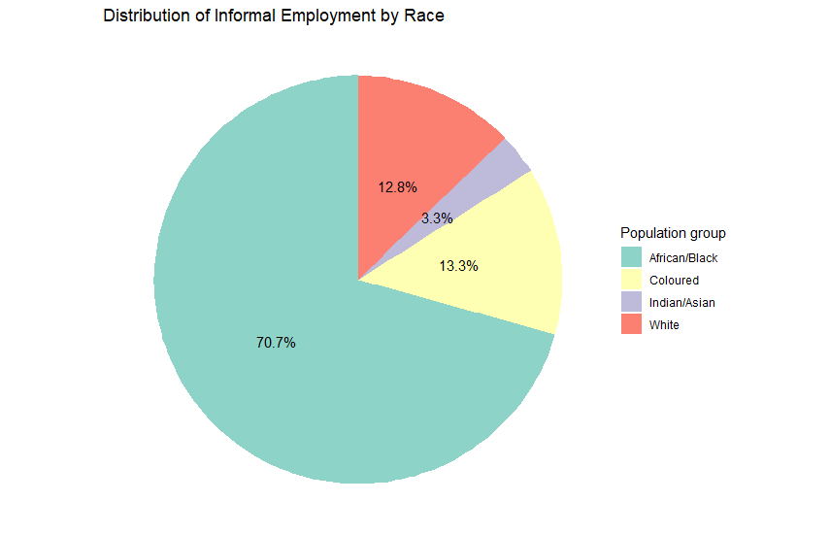
Figure 1.1
Figure 1.1 shows the relationship of informal employment by population group for the year 2023 of quarter 4. This study has a view that in the population group, most Africans are dominant in informal employment by 70.7%, this result illustrates that most Africans are unemployed followed by coloured at 13.3% and white has a rate of 12.8%. By studying this result, indicates that most Africans are less like to be employed in the formal sector. The high rate of Unemployment led people starting their own business to make a living. This result indicates that most people who will be found in the informal sector are African and coloured due to their population size. White and Indian populations indicate that most have better access to formal employment. The higher participation in informal employment reflects that most people will end up unemployed. South African informal economy plays a significant role in economic growth because it helps to reduce poverty. This analysis indicates that the government should suggest policy measures in improving the condition of the informal sector but most likely on the African population.

Percentage of Participants of Employment Status by Gender and Education Status
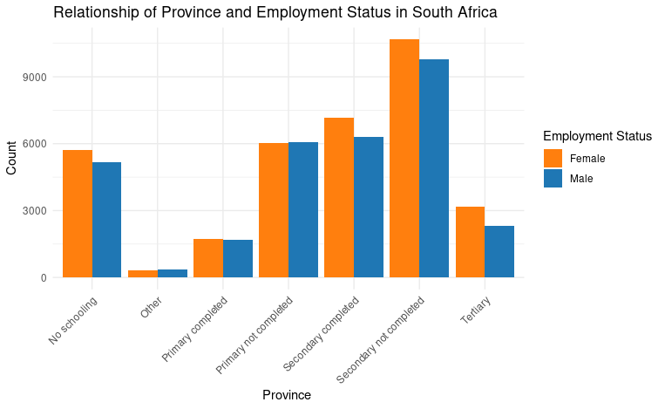
Figure 1.2
Figure 1.2 illustrates the relationship between how education plays a role in the informal economy and how much it contributes to the economic growth of South Africa. The graph indicates that most people who are working in the informal sector are those who have dropped out or no education because this graph indicates that more than 3000 people have don't go to tertiary in both genders. The informal economy fills the labour gap by providing job opportunities for those who are undereducated or excluded from the formal sector. The secondary not completed categories have the highest count of more than 9000 for both males and females, this indicates that the informal sector absorbs workers with moderate education. A significant number of people with completed matric are also found in the informal sector due to barriers to working in the formal sector such as a lack of skills. Across the education levels of both genders, this implies that both men depend on the informal economy. This result indicates that most women are dominant in the informal sector, and some are facing discrimination.
Relationship of Province and Employment Status in South Africa
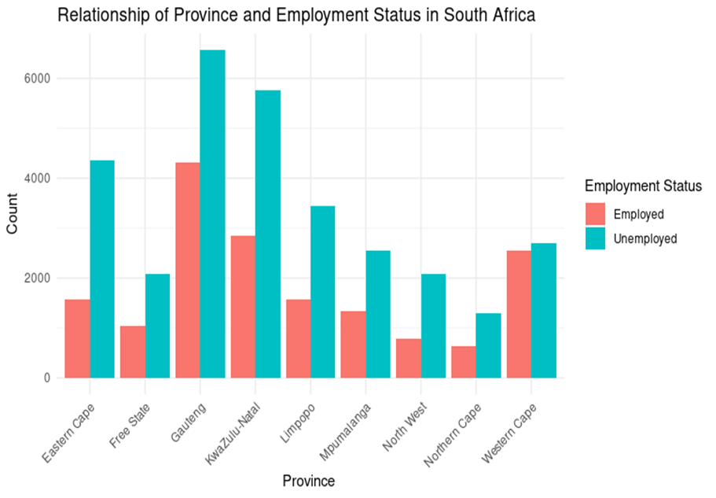
Figure 1.3
Figure 1.3 displays the result of the relationship of employment status in each province. Gauteng, KwaZulu Natal and Western Cape show that they have the highest count >2000 to 8000. This province is the most economically significant and attracts both formal and informal labour. The higher the rate of unemployment in this region, the higher the rate of labour market challenges. Mpumalanga and Limpopo have significant unemployed populations because this region is more rural and doesn't have much industry. Most provinces with high unemployment such as Gauteng Eastern Cape and Limpopo, indicate that the informal economy plays a significant contribution in absorbing labour that is not employed in the formal sector. Gauteng and Western Cape have a high rate of employment compared to other provinces because it has more than 2000 count, this reflects their settlement status as urban and industrialised. Furthermore, even in most developed regions, the is a significant reliability of the informal economy to access job opportunities for those who struggle to work in the formal sector. Most cities where the informal economy strives are Johannesburg and Cape Town such as domestic workers, transport and street vendors.
Relationship of Employment status in the sector by Gender
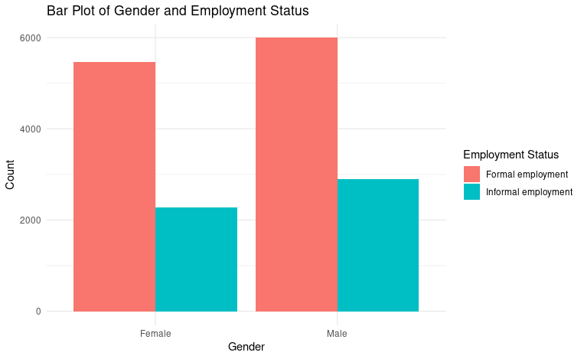
Figure 1.4
This result in Figure 1.4 illustrates the relationship of employment by gender in each sector. This graph shows that the higher formal employment in male categories is greater than in females, this indicates a higher proportion of males that are engaged in the formal sector for employment than females. The informal employment of females is shorter than males and this graph explains in more detail that more women are discriminated against due to gender inequality. This graph elaborates that more males are dominant to females, and this explains that more males work in the informal than women. This data shows the inequality between males and females in employment, females are less likely to be employed than males. Gender disparities in the informal sector need to be addressed because most females are being treated badly and not be able to find access to opportunities in the formal sector. The higher proportion of males indicates that the informal sector plays a role in the contribution to household income, but lack of formalization in the informal economy can limit the contribution of the informal economy to economic growth.
Relationship of Metro Code Province of Employment by Sector
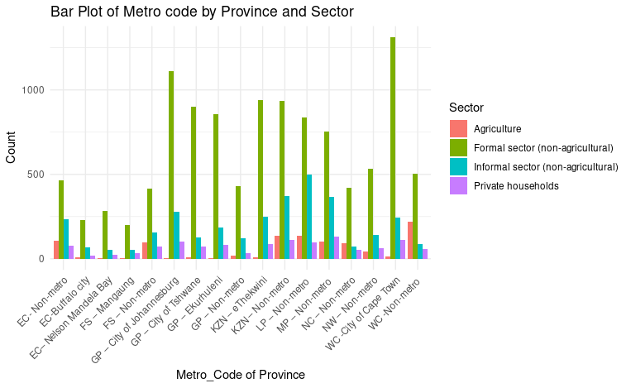
Figure 1.5
The findings in Figure 1.5 indicate the relationship of metro code of employment by each sector in the province. The informal sector (non-agricultural) has the highest number of labourers across most provinces that are metro codes, this results in the significant contribution to the South African labour market of this study to the economic growth. In the informal sector, agriculture plays a significant role in labour in some regions, such as non-metro code areas in the province. The city of Johannesburg and the city of Cape Town have a significant proportion in the formal sector(non-agricultural) which accounts for more than 1000. The dominance of the informal sector in some regions emphasizes its contribution to economic growth in regions where the formal sector is limited. The private households conclude that the is less labour who are domestic workers, and the informal sector provides job opportunities in regions where the is a high unemployment rate.
Relationship of the Age group of each Sector
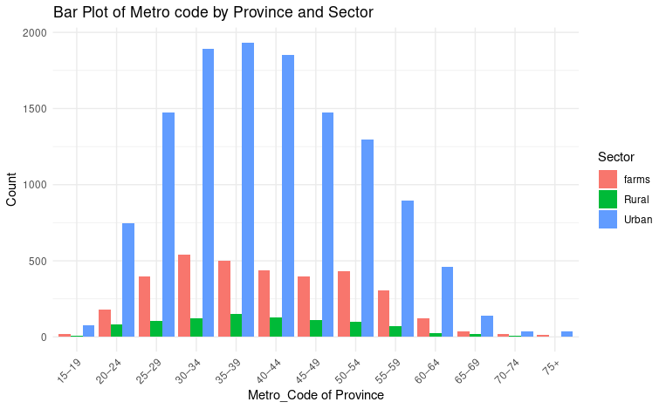
Figure 1.6
This graph supports our objective because it indicates that most people are employed in the CBD (Central Business District) in the urban area. The urban sector indicates that most people start working at the age of 15 and above to seek a green pasture due to a lack of skills and lack of education. Rural is relatively small because the are fewer job opportunities and most people move to the urban areas to look for employment. From the age group of 15 to 35, this graph indicates that most people start working and this states that the more the age group grow the more people in the urban area seek employment. An increase in age group also increases the population in urban. In the age group of 40-70, this graph shows, that most people stop working, some resign and the population in urban decreases (the more people grow older the less they work). The dominance of the urban sector indicates that the area is contributing to economic growth, for example city of Cape Town indicates that the is a more informal sector and that sector contributes to economic growth because it creates job opportunities. For the economy of the country to grow the government needs to support urban development by improving infrastructure in urban and rural areas and create training centers for informal economy.
  - CONCLUSION AND RECOMMENDATIONS
The investigation of this study was to research the nature and significant contribution informal economy in the Western Cape. To achieve this objective, binary logistic regression was conducted to determine whether the demographic variables influence economic growth through the informal economy. This study concludes that informal employment contributed 31,12% in the year 2023 of quarter 4 this means that the informal economy has a significant contribution to South Africa's economic growth and labour market. Province, Age group, and education status contribute more to the informal economy Based on our analysis we concluded that gender does not significantly contribute to economic growth due to gender inequality. According to our analysis, we conclude that in quarter 4 of 2023 of QLFS, most males were dominant over females, this implies that most males were motivated to start their businesses in the informal sector. Simelane (2022) argues that most females are the ones who are dominant in the informal sector.
With regards to age group, our analysis concludes that it has a small influence on the informal economy for contribution to economic growth. The age group has shown that the more people move to the urban economy, the positive correlation that most of them end up in the informal sector due to a lack of skills or lack or education. An increase in age group contributes to the informal economy because the more people start their businesses, the more experience they gain to be able to move from the informal to the formal economy. From the age group of 35 to 39 most people are more dominant in their businesses and this shows that this is the highest mean score that most labourers have their business function well.
The informal labourers with no schooling gas an increase in both genders, this result that people who have no education are significantly found in the informal sector because it's the only way to make a living. An individual who has not completed secondary school has a strong correlation to work in the informal sector because due to a lack of skills and qualifications to work in the formal, they are shifted to the informal sector to avoid unemployment. According to Ngcobo(2021) support that earning a lower salary is slightly influenced by having a poor education attainment. Other has the lowest education level and this indicates that they are less motivated to find employment.
In the analysis of informal employment, the result illustrates that informal employment has a significant impact on the informal trades because it creates job opportunities for new labourers. This result concludes that being unemployed and having not enough capital, this had motivated most informal trades to start businesses for survival. Most females experience gender inequality in the informal sector because the is high competition to trade in selling their goods and services. This study is significant because they are demographic variables that contribute to economic growth in the Western Cape province, this area is in the Central Business District where the best services are imported and exported.
RECOMMENDATION
By analyzing the economic growth of South Africa, we can all see that the informal economy is rapidly increasing each year. Most of the employees who work in the informal sector are women and they are vulnerable because they are not government protected. The government should introduce this policy to the informal economy: Real life scenarios like Brazil and India. India used technology for formalization to informal workers, giving access to mobile applications that provide training and support and access to financial services through digital. While Brazil's government provide training and resources
- The government should provide opportunities for the informal sector for loans or financial assistance.
- Mentoring young people about formal and informal economy, providing education learning in high school.
- Design an approach for training and skills development.
- Increase infrastructure for informal labourers.
- The government should provide social security for informal labour.
Strategy for informal economy:
NIBUS (National Informal Business Upliftment Strategy – is used to support informal businesses, address their challenges and provide them with solutions to their challenges
SETA Training Programs- provide training and skills to informal workers to improve productivity and to learn new skills of entrepreneurship to be able to survive.
APPENDIX.A Statistical Output
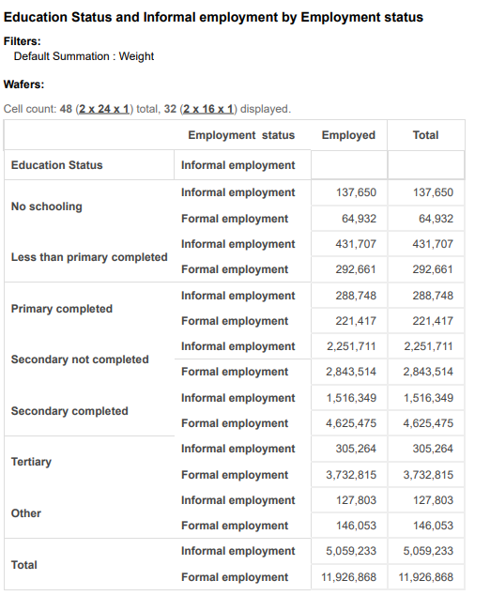

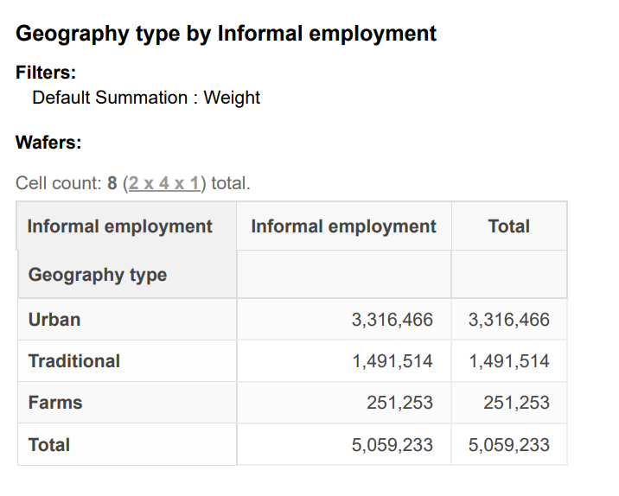

REFERENCES
Hart, K., 1973. Informal income opportunities and urban employment in Ghana. The Journal of Modern African Studies, 11(1), pp.61-89.
Ntuli, I.S., 2020. Informal trading in post-apartheid South Africa: an examination of the experiences of black African women street traders in Durban (Doctoral dissertation).
Tawodzera, G. and Chikanda, A., 2016. International Migrants and Refugees in Cape Townís Informal Economy. OSSREA.
Rodríguez-Pose, A., 2002. The role of the ILO in implementing local economic development strategies in a globalized world.
Rogan, M. and Skinner, C., 2017. The nature of the South African informal sector is reflected in the quarterly labour-force survey, 2008-2014. Capetown: University of Capetown.
Stats, S.A., 2011. Statistics South Africa. Formal census, 1, pp.79-106.
Skinner, C., 2002. Understanding formal and informal economy labour market dynamics: A conceptual and statistical review concerning South Africa (p. 25). Durban: School of Development Studies, University of Natal.
Brown, M., 2010. Review on the environment of women workers in the informal economy in South Africa.
Kabeer, N., 2008. Mainstreaming gender in social protection for the informal economy. Commonwealth Secretariat.
WIEGO. 2012. The Informal Economy in Arab Nations: A Comparative Perspective.
Thomas, M.A., 2012. The informal economy: Definitions, theories and policies.
Heintz, J. and Pollin, R., 2003. Informalization, economic growth and the challenge of creating viable labour standards in developing countries.
Statistics South Africa. 2020. Quarterly labour force survey. Pretoria, South Africa
Ngcobo, N.N.P., 2021. The informal economy for local economic development in South Africa: A constitutional law approach (Doctoral dissertation, North-West University (South Africa)).
Vanek, J., Chen, M.A., Carré, F., Heintz, J. and Hussmanns, R., 2014. Statistics on the informal economy: Definitions, regional estimates and challenges. Women in Informal Employment: Globalizing and Organizing (WIEGO) Working Paper (Statistics), 2(1), pp.47-59.
Ligthelm, A.A., 2004. Profile of informal microenterprises in the retail sector of South Africa. Southern African Business Review, 8(1), pp.39-52.
Seekings, J. and Nattrass, N., 2008. Class, race, and inequality in South Africa. Yale University Press.
Kantor, H., 1999. Race, education, and joblessness in the inner city, 1970–1990. The Urban Review, 31(3), pp.225-242.
Simelane, S.L., 2022. Culture as an external determinant of the education system of BRICS member states: a comparative study (Doctoral dissertation, North-West University (South Africa).).
McKeever, M., 1998. Reproduced inequality: Participation and success in the South African informal economy. Social Forces, 76(4), pp.1209-1241.
Fourie, F., 2019. Evolving policy paradigms: The National Development Plan, employment and the informal sector in South Africa. Research Gate, pp.385-411.
Hussmanns, R., 2004. Measuring the informal economy: From employment in the informal sector to informal employment (Vol. 53, p. 32). Geneva: Policy Integration Department, Bureau of Statistics, International Labour Office.
Tokman, V.E., 1980. The influence of the urban informal sector on economic inequality. In Work, income and inequality: Payment’s systems in the third world (pp. 108-137). London: Palgrave Macmillan UK.
Delgado-Prieto, L., 2024. Immigration, wages, and employment under informal labour markets. Journal of Population Economics, 37(2), p.55.
Rogerson, C.M., 2018. Informality and migrant entrepreneurs in Cape Town’s inner city. Bulletin of Geography. Socio-economic Series, (40), pp.157-171.
Johnson, D., 2016. Migrancy and Thabo Mbeki's African Renaissance. In The Cultures of Economic Migration (pp. 127-140). Routledge.
De Lille, P. and Kesson, C., 2017. View from City Hall: Reflections on Governing Cape Town. Jonathan Ball Publishers.
King, A. and Shackleton, C.M., 2022. Working in poverty: Informal employment of household gardeners in Eastern Cape towns, South Africa. Development Southern Africa, 39(6), pp.1007-1020.
Banik, D. ed., 2013. The legal empowerment agenda: poverty, labour and the informal economy in Africa. Ashgate Publishing, Ltd.

